FOR IMMEDIATE RELEASE SHOWROOM: 101 S. Hamilton

Contact: Mary Leigh Howell
ml@maryleighhowell.com
(336) 317-7713

UNIVERSAL FURNITURE TO HOST HALF UNITED AT FALL MARKET

Pop-up shop at Universal’s showroom will feature socially-good goods

HIGH POINT, N.C., Oct. 4, 2022 – Universal Furniture will host nonprofit HALF UNITED at its showroom and Learning Center during High Point Market this fall. HALF UNITED is a North Carolina-based brand that fights hunger and poverty through the sale of home goods and apparel made by artisans in Haiti, Peru, Mexico and other countries.

“Universal Furniture is honored to host HALF UNITED during Market this fall,” said Vice President of Marketing Neil MacKenzie. “Their mission of using employment to change lives is inspirational and admirable.”

The organization will have a pop-up shop in the Universal showroom from Friday, October 21 to Tuesday, October 25, to sell their socially-good goods. On Friday, Oct. 21 at 2p.m., HALF UNITED co-founder Carmin Black will be the featured speaker in the Learning Center, discussing how gainful employment is the number one way to fight global hunger.

HALF UNITED currently works in Peru, Djibouti, Morocco, India, Haiti, Mexico, the USA, and Vietnam. Through their support of global gainful employment, the nonprofit has seen healthcare and land purchases increase and illiteracy decrease in the various communities they serve.

“In our earliest days, HALF UNITED donated seven meals per product sold. After giving away nearly 2 million meals, we were frustrated to learn that providing food for those in need does not equal ending hunger,” said Black. “We sought a new path toward ending hunger and poverty—holistically and sustainably—and realized that gainful employment has the power to end hunger.”

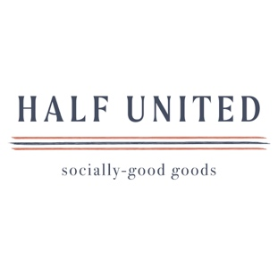

About Universal
Retailers and interior designers around the world trust Universal Furniture’s award-winning, smart and stylish designs to create modern, well-appointed living spaces for the whole home. The company’s casegood, upholstery, accent and outdoor designs are developed under the brand names Universal Furniture, Miranda Kerr Home and Coastal Living.

Universal Furniture, founded in 1968 and based in High Point, N.C., is the recipient of 13 Pinnacle awards for design excellence from the International Society of Furniture Designers. It is a brand of Samson Holdings, one of the world’s largest vertically integrated furniture manufacturers. For more information, please visit www.universalfurniture.com, or find us on Facebook, Instagram, and Pinterest @UniversalFurn.

# # #

