Press Contact: Andrea Romero
Vice President
Tel: 323-935-7600 ext 22
Email: andrea@thereelrossgroup.com
www.thereelrossgroup.com

Spain's Leading Furniture Brand Set To Debut New Additions for its
BOND and Coral Collection This Fall at High Point Market

Los Angeles- (8/25/22) - For over 82 years, Hurtado Furniture has distinguished itself as a high-quality furniture brand devoted to tradition and attention to detail. This Fall, HURTADO Furniture is set to make a big impression during High Point Market by unveiling new additions to its BOND and Coral Collection. The BOND Collection offers a contemporary feel with its wooden or marble top, geometric design, and metal accents on its base. The BOND Collection will complement the new additions for the Coral Collection, which has straight curves and uses luxury materials such as brass. As a celebration for the introductions, HURTADO will host a Hospitality Market welcome reception on Saturday, October 22, 2022 with light refreshments. The new additions will be available for viewing during Fall HPM from October 22-26, 2022, in showroom 208 W. English Road, NC 2726.

BOND Collection New Additions

The full BOND Collection includes a bedroom and occasional pieces that are offered in all finishes from evolution, all metals, and marble top options. The BOND Collection features geometric shapes and irregular plates in the designs that have become the signature style.
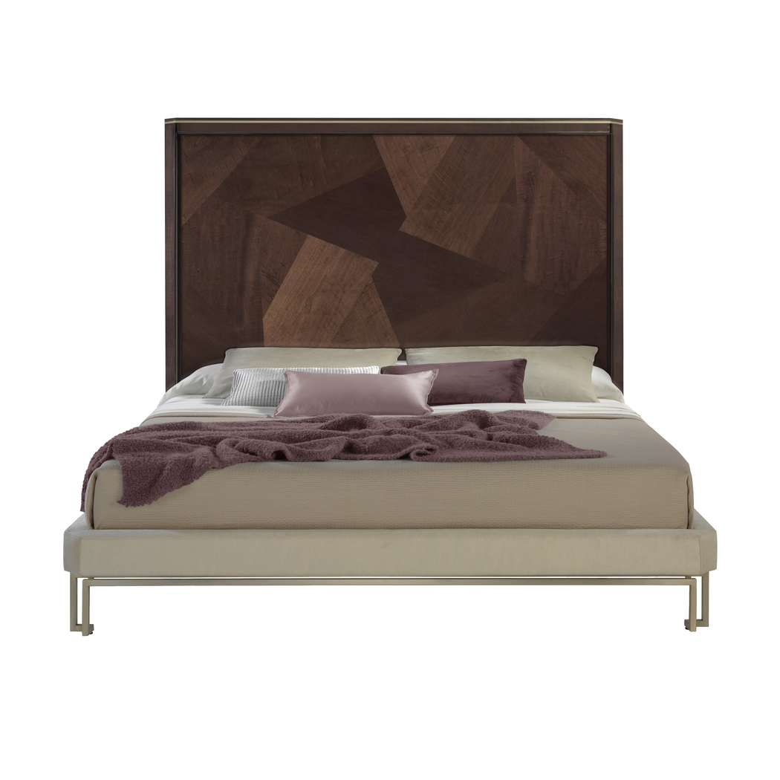
Introducing a new addition to the BOND bedroom collection, the BOND King Size Bed BOKP11 features a geometric-patterned wood headboard and a playful contemporary statement piece. The bed also features an upholstered footboard and rails.
Crafted in matte natural walnut with brass accents, this bed will give your home a fresh and luxurious look.

BOND King Size Bed
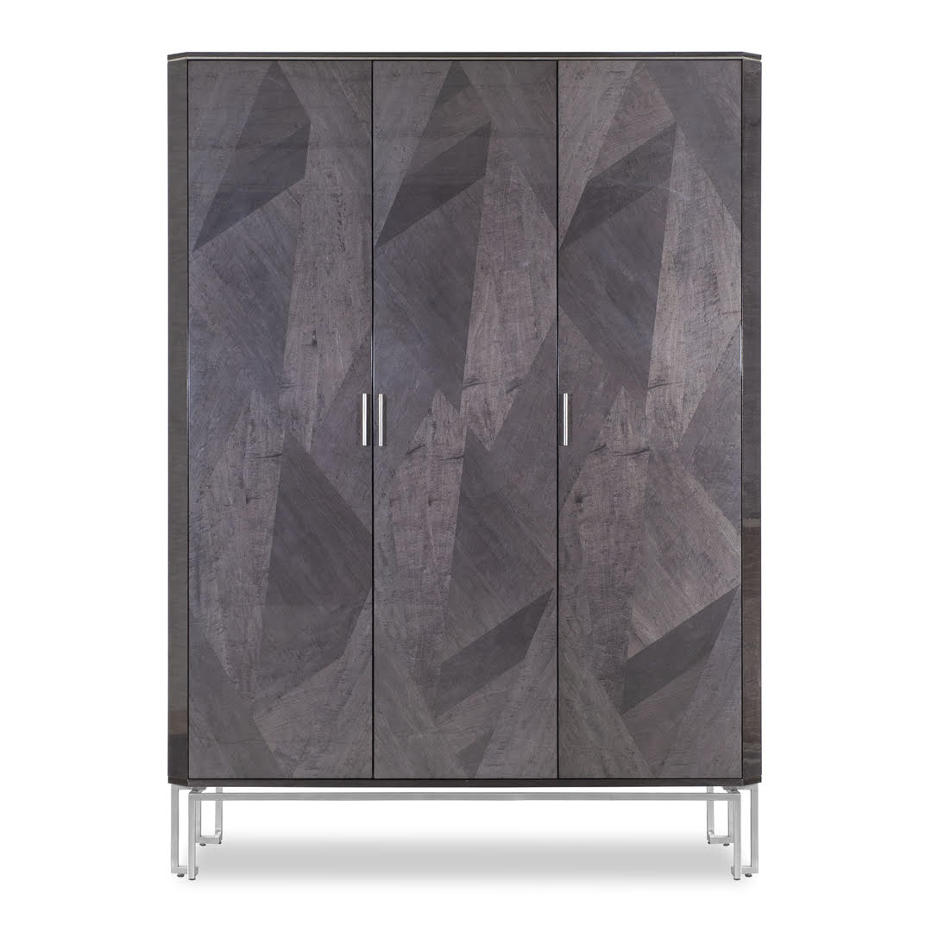

Enhance your bedroom space with the BOND Three-Door Wardrobe BO4014. This piece combines artistic design and unique geometric shapes to create a signature style. Featuring two drawers, six shelves, and one hanging bar, you'll have plenty of room for your wardrobe essentials. A LED light is added to illuminate the inside of the unit.

BOND Three Door Wardrobe
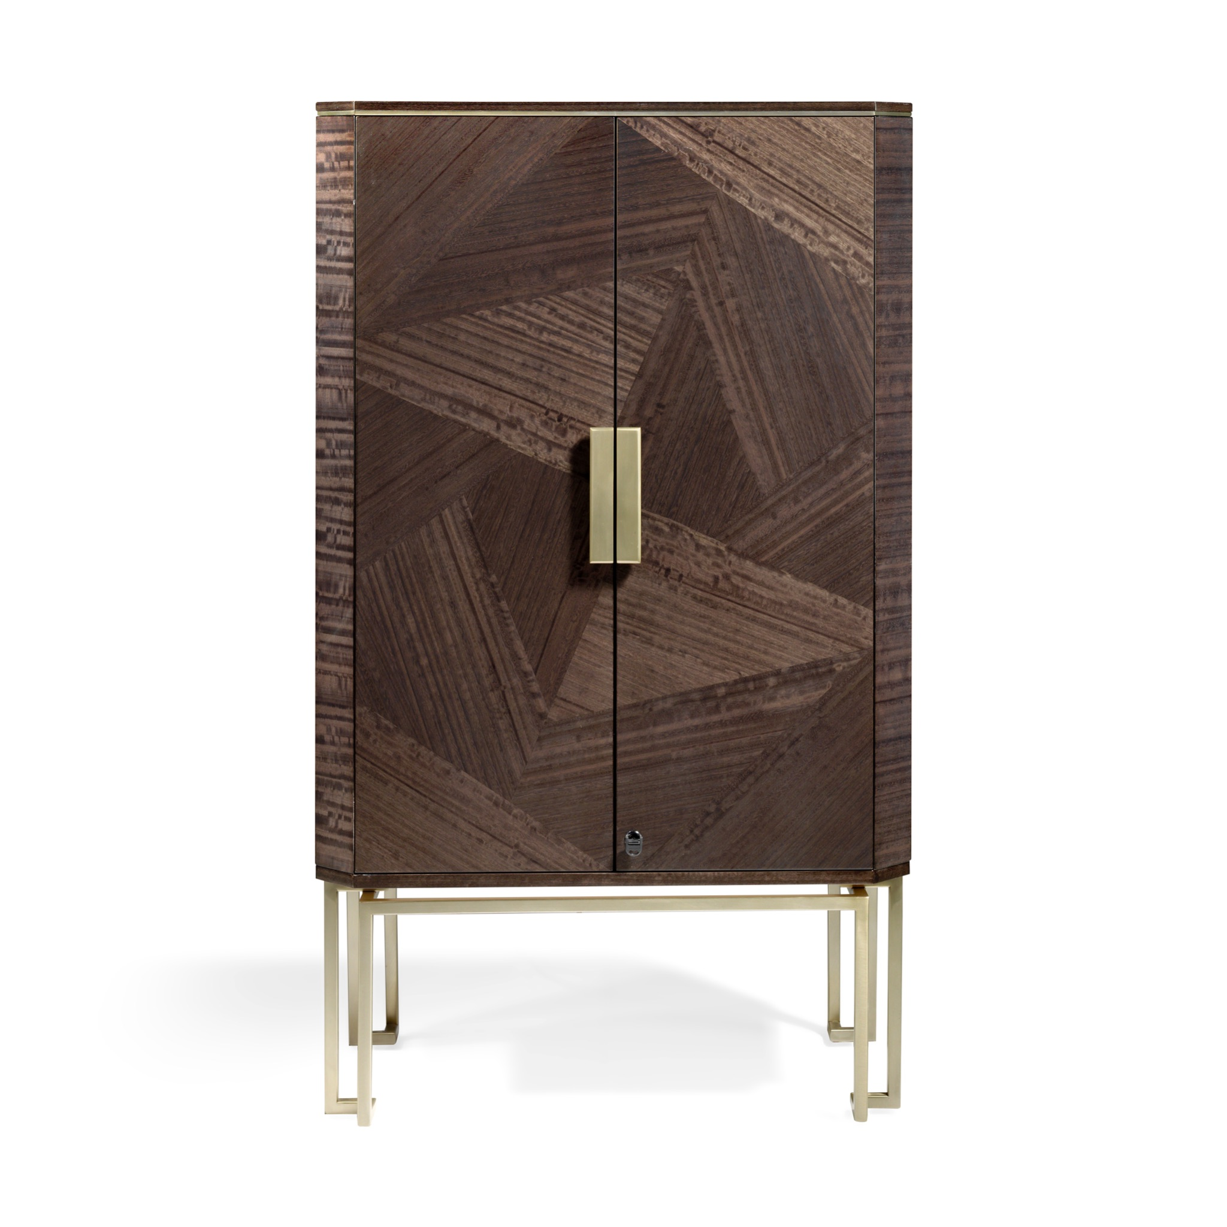

Keep your valued jewels safe with the BOND Jewelry Armoire BO4011. Perfect for stylish storage, this elegant armoire creates a functional and luxurious spot to store your valuables. Crafted in High Sheen Gray Frize Eucalyptus, the new piece features three large and five small drawers with compartments for optimal storage. Its smooth, sleek design lets you easily organize your most valued pieces.

BOND Jewelry Armoire
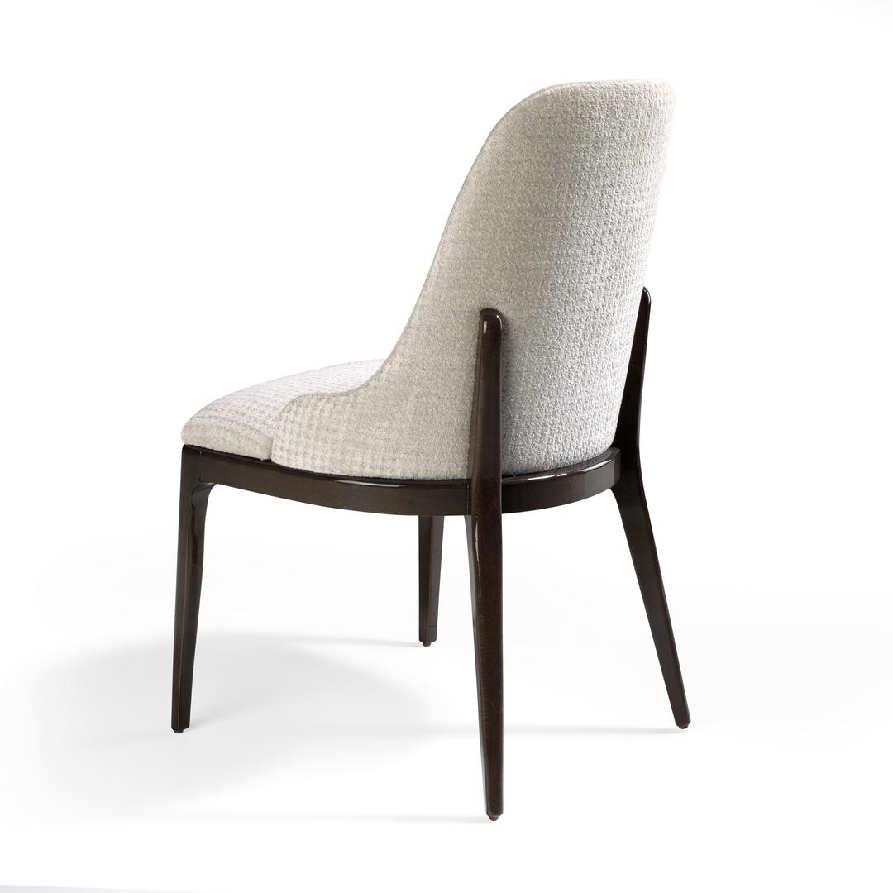

The BOND Armchair 548200 will be a great addition to your living room, adding sophistication to its environment. The standout feature of this model is the back of the chair, which has an extended wooden base that adds support and more definition to the piece. All our models are made of solid wood, some with metal structures and upholstered with rich fabrics. Both finishes and upholstery, and leather, can be modified.

BOND Armchair

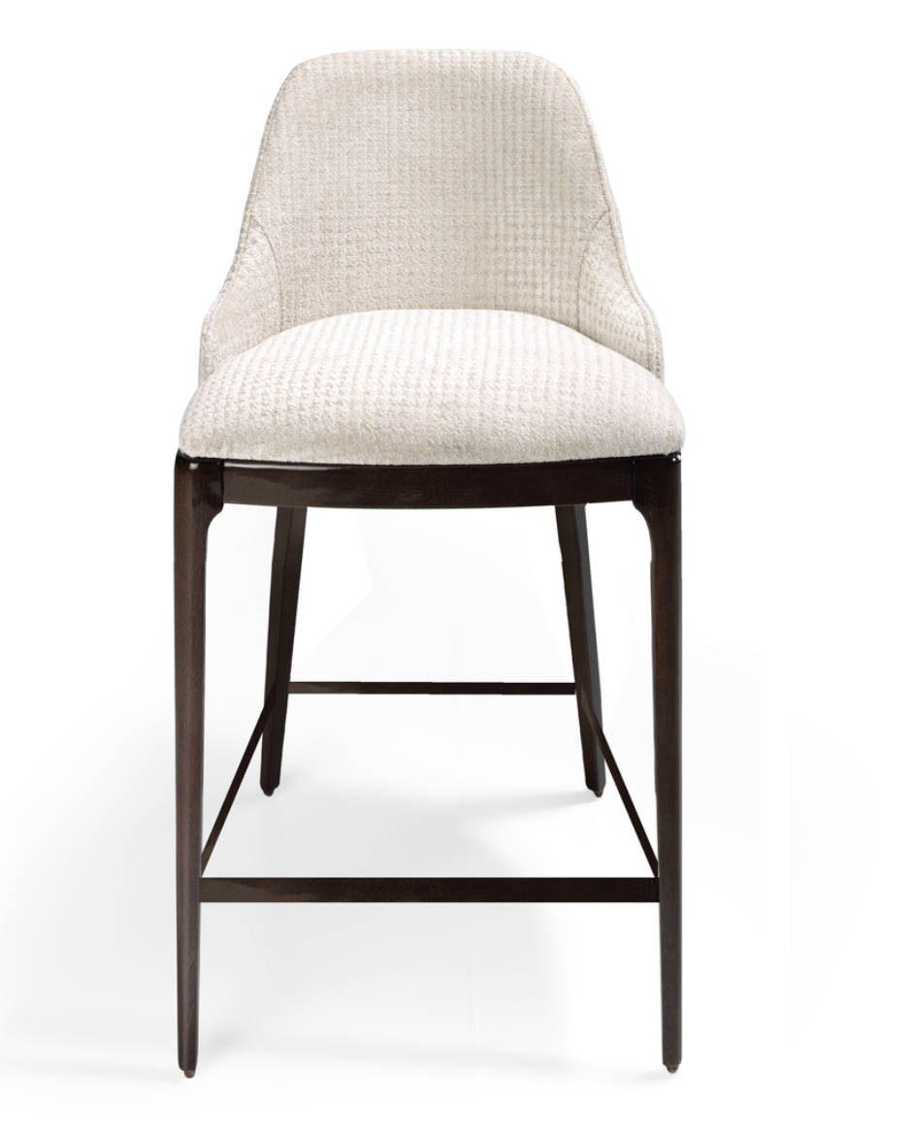

The BOND Bar Stool 548201 features HURTADO’s signature style of geometric designs. All our models are made of solid wood, some with metal structures and upholstered with rich fabrics. The Bar Stool is available in two different heights (bar height and counter height). Both finishes and upholstery, and leather, can be modified.

BOND Bar Stool

Coral Collection New Additions
The CORAL Collection by Hurtado is composed of sharp notes, having their equivalent in the most delicate designs and serious notes that convey strength and robustness. Each design forms its own set, like an “Author’s Collection,” and threads together to create a harmonic composition.
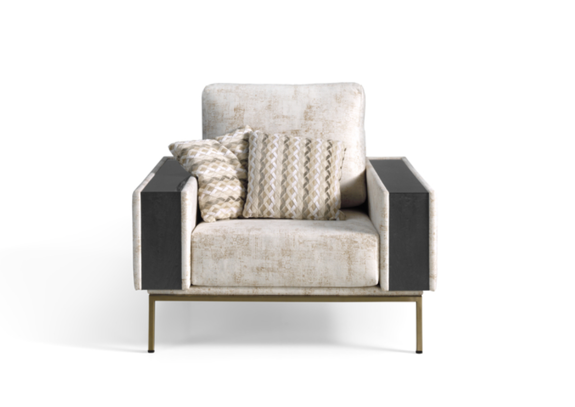

Bring a touch of elegant flair to your entertainment space with the Coral Sofa Armchair SCR001. These pieces are handcrafted with metal bases with legs and wood inlays on the arms, making them the ideal centerpiece for your living area. As part of the Evolution collection, these pieces are available in different wood and metal finishes.

Coral Sofa Armchair

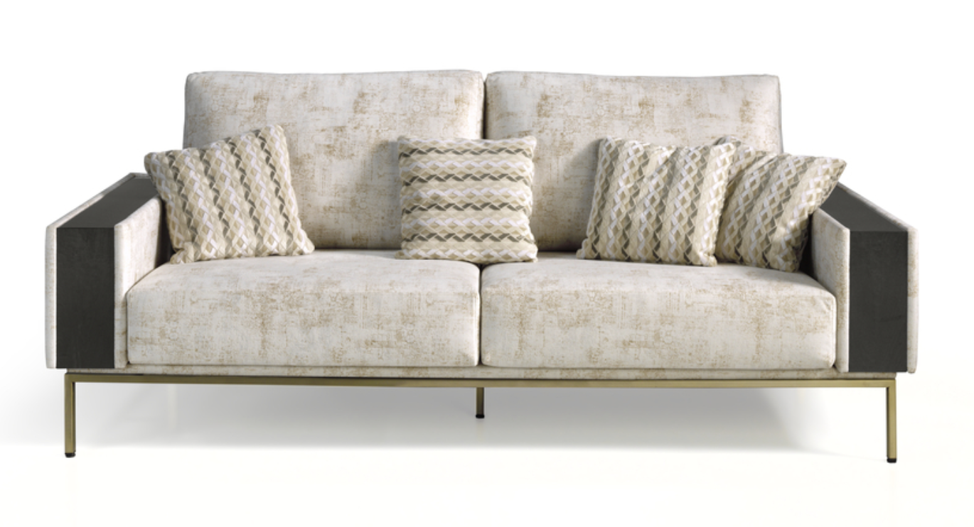
Elevate the comfort and style of your entertainment space with the new Coral Sectional Sofas SCR003. These are made with Hurtado’s high-quality materials, handcrafted with a metal base with legs, and have wood inlays on the arms. The sofas display an elegant, stylish appeal that is perfect for a contemporary or modern home.

Coral Sectional Sofa

###
ABOUT HURTADO:
Founded in 1940 in Spain, HURTADO’s beginnings consisted of making altar pieces from marble and wood in South America, Central America and Spain. HURTADO is one of Spain’s leading manufacturers of upscale and European-style furniture with a presence in more than 50 countries including the United States and India as well as countries in Europe, Asia, the Middle East, and South America. HURTADO also has an office, showroom, and distribution center in High Point, North Carolina. HURTADO is now a third-generation company that has grown into an internationally renowned furniture producer at high-end furniture by preserving the hallmarks and traditions of the HURTADO brand. For more information, please visit the official website: www.hurtadofurniture.com.

