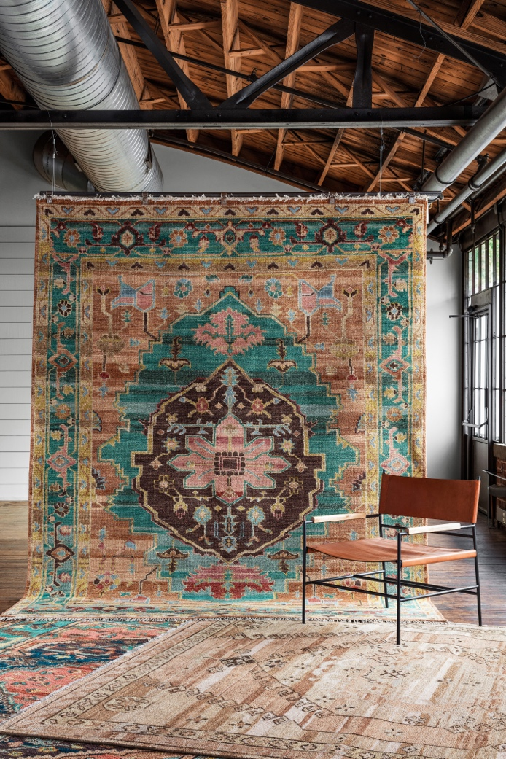

JAIPUR LIVING OFFERS CUSTOMERS BOLD INSPIRATION
FOR ITS FIRST LAUNCH OF 2021

FOR IMMEDIATE RELEASE

(ACWORTH, GA – DECEMBER 17, 2020) -- Global rug and textiles furnishings company Jaipur Living ushers in the New Year with a product launch brimming with bold inspiration. More than 100 rugs make their debut across 12 new and six existing collections--including almost 75 family-friendly powerloomed and easy-care performance options. They will be shoppable via Jaipur Living’s website in January.

“We have some really fresh and new powerloomed rugs that aren’t like anything else you would see out in the market,” said Jaipur Living Director of Product Development Steven Sorrow. “In terms of colors and designs we have looks that are often overlooked by other U.S. rug companies.”

HIGHLIGHTS
- The striking WunderKammer collection from new licensee Matteo Cibic finds its bold inspiration in iconic Indian architecture
- Award-winning designer Kavi introduces two collections – Aakar and Aakar Naturals
- Jaipur Living’s best-selling Polaris collection gets 25 bold new additions
- The Jinsen collection impresses with vintge-inspired patterns and invigorating colors

TRENDS
- Iconic – rug designs guided by architecture and other man-made formations
- Simply Put – modern solids with subtle textures that simplify design decisions
- Old Modernity – eroded traditionals with a high-end vintage look at accessible prices
- Turkish Sunfades – purposefully-faded designs inspired by Turkish rugs

HAND-KNOTTED

New! AKK01 Aakar by Kavi Brumoso
Aakar by Kavi is an exquisite Persian hand-knotted rug of viscose and wool that offers a modern twist on the traditional screen pattern. The Brumoso design’s striking gray and red colorway plays well in modern and transitional decors.

New! ANK01 Aakar Naturals by Kavi Mismo 2
A geometric mid-century modern pattern makes the Aakar Natural by Kavi collection a playful option for modern and transitional rooms. Mismo 2 features a soft, yet substantial blue and multicolor palette hand-knotted in wool and rayon made from bamboo.

Tattvam by Kavi Sahaj
A subtle opulence and painterly wash of and blue and brown give this new addition to the Persian hand-knotted Tattvam collection a grounded sense of artistry. Sahaj displays an intricate lattice design for a touch of global flair. In wool and rayon made from bamboo.

New! JIN01 Jinsen Ziba
Handspun yarn and a rustic knotting technique give the Jinsen collection a stunning textural surface. Traditional patterns look both vintage and fresh, and are available in strong or muted colors. The pink and yellow Ziba rug flaunts a medallion design.

New! LAC01 Lacuna Drass
A bold indigo base balanced by a delicate Persian-inspired pattern makes the Lacuna collection special. Hand-knotted in a blend of wool and silk, the Drass rug has a vintage look and updated traditional style.

New! MNI02 Manifest Curium
The Manifest collection is hand-knotted in an exclusive blend of Afghani wool that creates lots of color and movement in the yarn. North African-inspired designs are available in two neutral colorways that work well in global and modern homes.

HANDTUFTED

JWK01 Jaipur WunderKammer Royal Patio
The Jaipur WunderKammer collection’s Royal Patio rug finds its inspiration in the archetypical Jharoka, or balconies and arches of Jaipur, India. Handtufted in a stately blend of gray and red wool and viscose and perfect for modern spaces.

PERFORMANCE

POL44 Polaris Cisero
POL46 Polaris Genessee
The popular Polaris collection gets a shot of espresso with 25 new rugs in fresh, updated patterns and colors. Highly versatile as well as durable in a 100% polypropylene construction, these rugs are an easy-care option for homes with kids and pets.
POWERLOOMED

New! EBC06 En Blanc Airi
Elegant En Blanc is a designer-friendly collection of powerloomed rugs in soft whites, creams, and grays. The Airi rug’s abstract pattern pops in a high-low pile that’s loaded with texture. A super high end look at an accessible price point.

DSH26 Dash Beatrix
The crowd-pleasing Dash collection gets five new additions of striking hand-painted floral rugs that align with the Grandmillennial trend. A super dense weave in 100% polypropylene make these rugs durable and cleanable, and perfect for high-traffic areas.

KND10 Kindred Kaden
The Kindred collection melds the timelessness of vintage designs with modern, livable style. The low-pile polyester Kaden rug has a soft, handknot-like texture in a pink and blue digitally-printed medallion design.

New! TRR02 Terra Demeter
Natural colors play with deep, rich tones to create the beautiful and textural Terra collection. Space-dyed polyester is combined with shrink polyester for an authentic Wabi Sabi effect.
Demeter’s abstract pattern is at home in modern and global décor.

New! TUN09 Tunderra Trevena
A marriage of multi-texture shrink and luxe polyester creates a high-end look at an accessible price in the new Tunderra collection. Trevena’s bold, abstract design works well in modern spaces and high-traffic areas.

ACCESSORIES

New! TDM01 Tandem Harlowe
A 100% PET fiber performance pouf in an elegant jacquard medallion pattern, the new Tandem collection Harlowe pouf brings an indoor energy to outdoor spaces.

ABOUT JAIPUR LIVING
With a free-spirited creative aesthetic that celebrates individuality and the everyday, Jaipur Living imbues rugs and textiles for the home with an updated and unmistakable point of view. Inspired by a model that nurtures artisans and indigenous crafts around the globe, the company’s passion for people, product and design stems from a women-centric approach finely attuned to fashion trends and how we want to live today. Boutique-like collections are a cut above and a world apart, blending respect for the handmade with a focus on innovative constructions to create one of the fastest growing home furnishings companies in the U.S.
MORE INFORMATION:
www.jaipurliving.com

MEDIA CONTACT:
karen.waygood@jaipurliving.com

SOCIAL:
https://www.instagram.com/jaipurliving/
https://twitter.com/jaipurlivinginc
https://www.pinterest.com/JaipurLiving/
https://www.facebook.com/jaipurliving
https://www.linkedin.com/company/jaipur-living-inc

