April 5, 2016

For Immediate release

NEW Furniture Designs to Compliment Popular Décor Trends

Across the America’s

Dimplex North America is pleased to announce the 2016-2017 furniture collection with 10 NEW designs that feature electric fireplaces by Dimplex North America Ltd., the World Leader in Electric Fireplace Technology. Designed to appeal to the décor trends of consumers across the America’s, from traditional to contemporary, country to modern.

The Austin media console, for example features a distressed reclaimed finish with barn-style doors that slide on black metal gliders, making it a cozy addition to a rustic family room. The Charlotte, by contrast, is a white, open lattice-design wrapped around glass shelving, an ideal centrepiece for a bright, open Oceanside décor. The Reily media console features a grey veneer finish on the cabinet, supported by a sleek raw metal frame that reflects all things salvaged; the Reily adds a punch of Industrial flare to any room.

Each features Multi-Fire XD™ flame technology that realistically mimics the look of a fuel-burning fireplace, along with the ability to choose from a variety of color effects. Choose from the traditional look of Realogs™ made from charred, natural firewood, or the sophisticated diamond-like acrylic media which sparkles beneath the flames.

The accompanying fireplaces are both stylish and portable, and can be plugged into any standard household electrical outlet. These stylish models vary in size from the 24”-high by 62”-wide Max Console– available in Elm Brown or Carbonized Walnut finishes – to the 34” by 72” Camilla model which provides ample storage for both televisions and showcasing home accents.

When additional heating is required, the powerful efficient Comfort$aver Heating System warms any space using a thermostat accessible from the convenient remote control. While capable of heating up to 1,000-sq.ft.of living space, Dimplex media consoles and mantels have the ability to operate flames with or without heat, enabling homeowners to enjoy the ambiance of a fire year-round. And the glass at the front of the unit stays cool to the touch whether the heat is on or off.

About Dimplex North America Ltd.
Dimplex North America Ltd. is a subsidiary of the Glen Dimplex Group of Dublin, Ireland and a world leader in electric heating products. Dimplex is based in Ontario, Canada and operates two distribution facilities with over 400,000 square feet of space centrally located in Indianapolis, Indiana and Cambridge, Ontario Canada.
Dimplex North America Ltd. offers a wide range of furniture pieces including media consoles, mantels and accent furniture pieces in which integrate patented heat and flame technology in to their stylish designs. With nearly 2,000 square feet of display space at High Point Market and nearly 50 pieces to choose from the Dimplex Showroom 2308 is a must to explore this year.
-###-

Media Contact:

Jane Bradley
Director, Marketing and Communications
Dimplex North America Ltd.
(519) 650-3630 ext. 296
jbradley@dimplex.com
www.dimplex.com
@Dimplex_NA

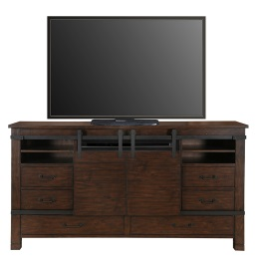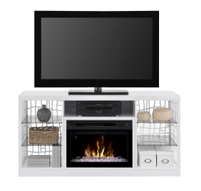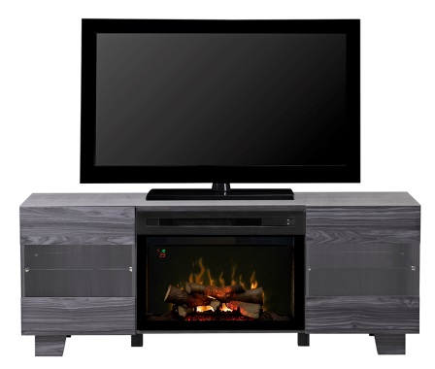
Austin - GDS33LD-1670HB Charlotte - GDS25LD-1579W Max - GDS25LD-1651CW

