FOR IMMEDIATE RELEASE

Press Inquiries: Andrea Romero
Vice President, The Ross Group
Tel: 323-935-7600 EXT 22
Email: andrea@thereelrossgroup.com

COMING THIS FALL: THE EMERALD, TRIANON, AND CHORAL BEDROOM COLLECTIONS BY HURTADO MUEBLES

Valencia, Spain. (Sep. 10, 2020) For years, Hurtado Muebles CEO and Creative Director Ana Hurtado has been inspired by her travels around the world. Form those journeys and inspirations, she has guided the brand in creating one-of-a-kind pieces, which have distinguished Hurtado Muebles from other luxury brands. Hurtado’s fall lineup will feature some signature Hurtado traits, while introducing some fresh and exciting new design elements. This fall, Hurtado will be unveiling the brand-new Emerald Collection, Trianon Collection, and Choral Bedroom Collection.

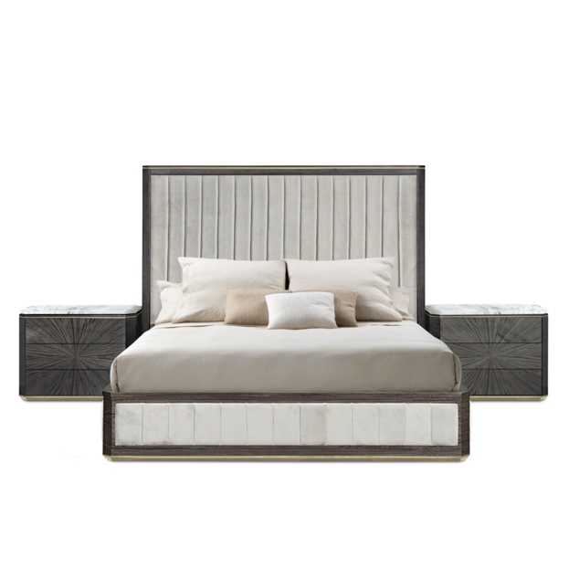
As with all of the previous Hurtado collections, the Emerald Collection holds a certain timeless elegance and effortless sophistication. A theme within the Emerald Collection is the use of straight lines to create a particularly luxurious look. The use of high-quality metals, finishes, and fabrics is also displayed beautifully in the latest bed frame design, and once again straight lines are used to emphasize the modernity and sophistication of the collection.

The Emerald Bedroom Collection features metal accents and is upholstered in Hurtado's luxurious fabric on the base of the frame and the headboard. The new bed frame will be offered with optional side tables, available in the Hurtado Evolution finishes of six metal and six marble to choose from.

The entire Emerald Bedroom Collection creates a beautiful, restful sanctuary.

Looking at the Trianon Collection, the designs here exude a regal and classic appeal. One of the more traditionally gorgeous designs in the Trianon Collection is the brown oak credenza [pictured below]. This beautiful design features four doors and one drawer along the top. The attention to detail in this piece is particularly stunning. Like every other Hurtado design, this piece is produced according to traditional hand-crafting techniques and uses the most advanced technology in systems of production and quality control.

(More)
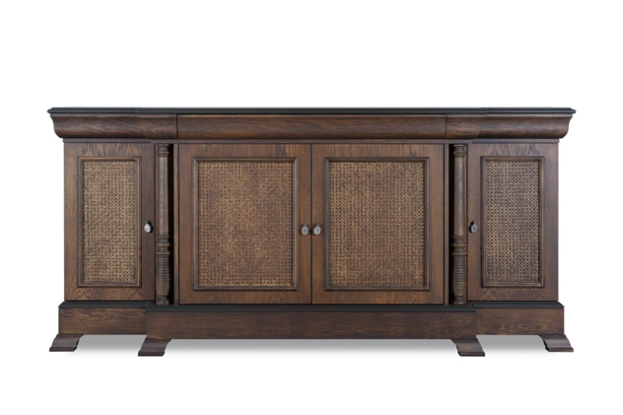
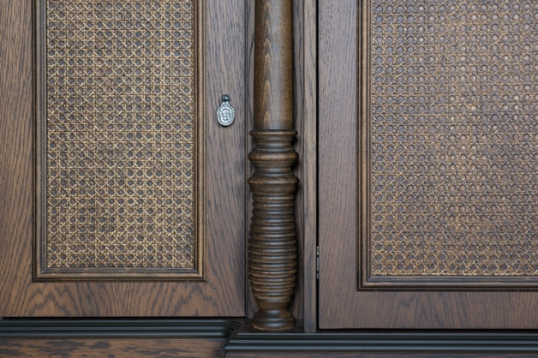

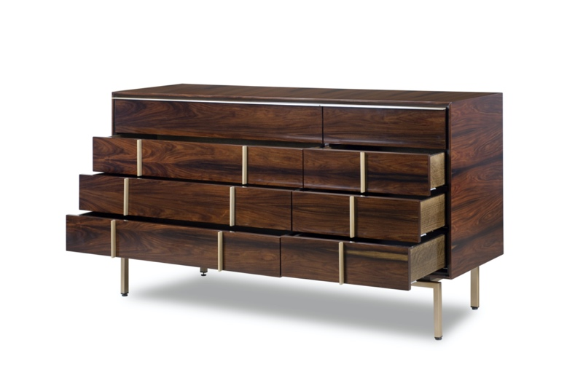
To top off the list of exciting new releases, Hurtado will be presenting the Choral Bedroom Collection. Similar to the Emerald Collection with its use of straight lines and clean design, the Choral Bedroom will offer more contemporary pieces. The perfect balance of form and function is found in the Choral chest of drawers [pictured below in Dark Rosewood]. This beautiful piece comes with four tiers of drawers which are divided for ease of organization. This dresser provides ample storage space while maintaining an intriguing, modern design with its unique metal handles and legs. The entire Choral Bedroom Collection will be available in all the evolution finishes and metal options.
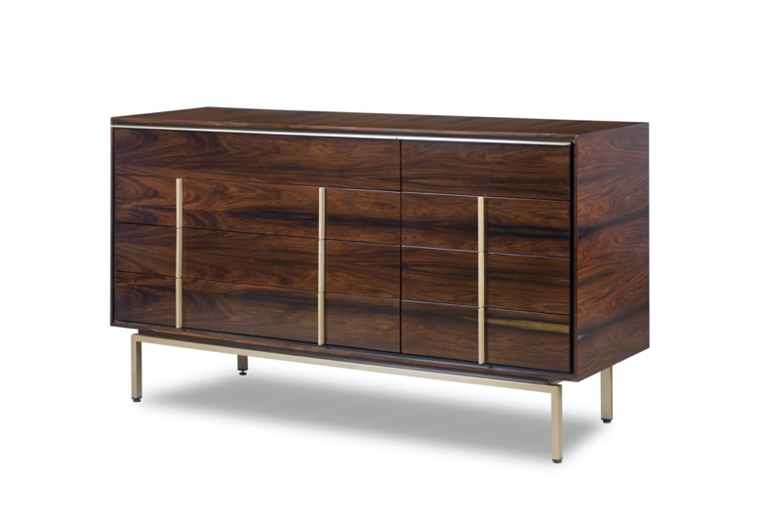

(More)
Ana Hurtado is excited to announce these upcoming collections, which will further distinguish Hurtado Muebles with their worldly inspirations, superb design, hints of modern flare and nods to traditional design. Hurtado continues to offer its clients the highest quality pieces, crafted to last for generations, as the brand itself has.

ABOUT HURTADO:
Founded in 1940 in Spain, HURTADO’s beginnings consisted of making altar pieces from marble and wood in South America, Central America and Spain. HURTADO is one of Spain’s leading manufacturers of upscale and European-style furniture with a presence in more than 50 countries including the United States and India as well as countries in Europe, Asia, the Middle East, and South America. HURTADO also has an office, showroom, and distribution center in High Point, North Carolina. HURTADO is now a third-generation company that has grown into an internationally renowned furniture producer at high-end furniture by preserving the hallmarks and traditions of the HURTADO brand. For more information, please visit the official website: www.HURTADOfurniture.com

###

