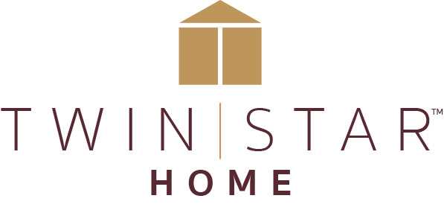

FOR IMMEDIATE RELEASE Media Contact: Tara Hackman
tara@gefenmarketing.com
336.884.5020

TWIN STAR HOME SPANS THE DECADES WITH NEW MID-CENTURY MODERN
TROMPE L’OEIL COLLECTION AND 18th-CENTURY INSPIRED CONCORD COLLECTION
Packed with function, the two new collections give consumers plenty of options

Delray Beach, FL (September 26, 2018)—Twin Star Home, an award-winning specialist in integrating home furnishings and the market leader in electric fireplaces, offers classics with a twist this market in two new collections that marry proven styles with unexpected and forward-thinking functional features. Both collections reflect the Twin Star approach, which integrates consumer insights into great design.

With everything from reversible doors to multi-functional cabinets, the urbane ‘60s-inspired Trompe L’oeil collection offers consumers many of the features of custom furniture at a fraction of the cost. The collection, veneered in warm walnut, takes its name—trompe l’oeil means “fool the eye” in French-- from signature panels of chevron marquetry in walnut, bird’s eye maple, and American cherry that give the illusion of three-dimensional depth. The collection’s flagship pieces include a multifunctional TV stand with a center compartment that can be used for storage or can be upgraded to accommodate a ClassicFlame® 26” quartz electric fireplace. The fireplace features Spectrafire®3D, a patent pending three-dimensional flame effect technology for the most realistic flames that dance on and behind the logs, including five adjustable color, brightness and speed settings. The fireplace’s 5,200 BTU heater provides supplemental zone heating for up to 1,000 square feet and can be operated with or without heat. A second TV stand can accommodate an 18” ClassicFlame® fireplace insert and comes with Bluetooth® speakers. Both cabinets feature reversible doors with marquetry in a sunburst pattern on one side and plain walnut on the other.

Other pieces in the Trompe L’oeil collection include an adjustable-height desk with programmable height settings and built in charging stations; a sleek coffee table with a sunburst veneer top; a side table with a marquetry top; and a stylish round tripod side table, available with a marquetry top or a plain walnut top. Modular pieces include a two-door cabinet with an adjustable shelf and a full extension sliding shelf; a three-drawer cabinet; a three-shelf hutch with optional glass doors that can fit on either the door cabinet of the drawer cabinet; and a walnut light bridge with LED touch lighting that can connect the two hutches.

The Concord collection translates the best of classically simple American Shaker design into a series of handsome multi-functional pieces. Based on original antiques from Shaker communities settled in New England during the late 18th and early 19th centuries, Concord is designed to meet the growing demand for clean, updated cottage looks that mix easily with other styles and can be dressed up or dressed down. Beautifully proportioned and thoughtfully detailed, the clean-lined and versatile Concord collection is particularly appropriate for compact living spaces.

Concord, offered in warm Meridian Cherry natural finish and a traditional Franklin Blue painted finish, is accented with satin brass hardware inspired by antique buttons. The broad and creatively functional collection includes entertainment pieces, storage pieces, occasional furniture, and home office pieces, with everything from TV stands with electric fireplace options to a file cabinet on casters with hidden built-in charging stations. The handsome four-door TV cabinet that is the signature piece of the collection can support a television up to 65 inches; the cabinet’s center compartment can also be converted to feature a ClassicFlame® Electric Fireplace with patent-pending Spectrafire® 3D three-dimensional flame effect technology. Other pieces include a bookcase with shelves above and a cabinet below that can be outfitted with storage for twelve wine bottles or a 19-inch quartz electric fireplace; and a working grandfather-style clock with built-in shelves and wine storage

“We are thrilled to introduce these new collections in High Point. Both are the result of understanding what’s important to our consumers and then putting what we learn into action,” said Lisa Cody, Twin Star Home’s Vice President of Marketing. “The breadth of design combined with flexibility and the multi-functionality options reflect the way our customers want to live now—with style, with comfort, and with their own personal stamp.”

###

About Twin Star:
Twin Star Home of Delray Beach, FL is an award-winning manufacturer of home furnishings, including electric fireplaces and furniture, many with integrated media solutions. Twin Star Home combines the latest trends with consumer-driven innovation and design-rich style to create lasting products that enhance consumers’ lives. Twin Star Home is recognized for its trusted national brands: ClassicFlame®, Duraflame, Bell’O, Tresanti and ChimneyFree. Find out more at www.twinstarhome.com.

Twin Star Home Product Information
Link for Images: https://gefenmarketing.sharefile.com/d-s9c826fc11544373b

Twin Star Home Concord Room Scene
Featured in this image: File Cabinet with Barrister Book Shelf, additional Barrister Book Shelves, Wine Storage Bar Clock, TV Stand with optional ClassicFlame® Electric Fireplace, and Coffee Table

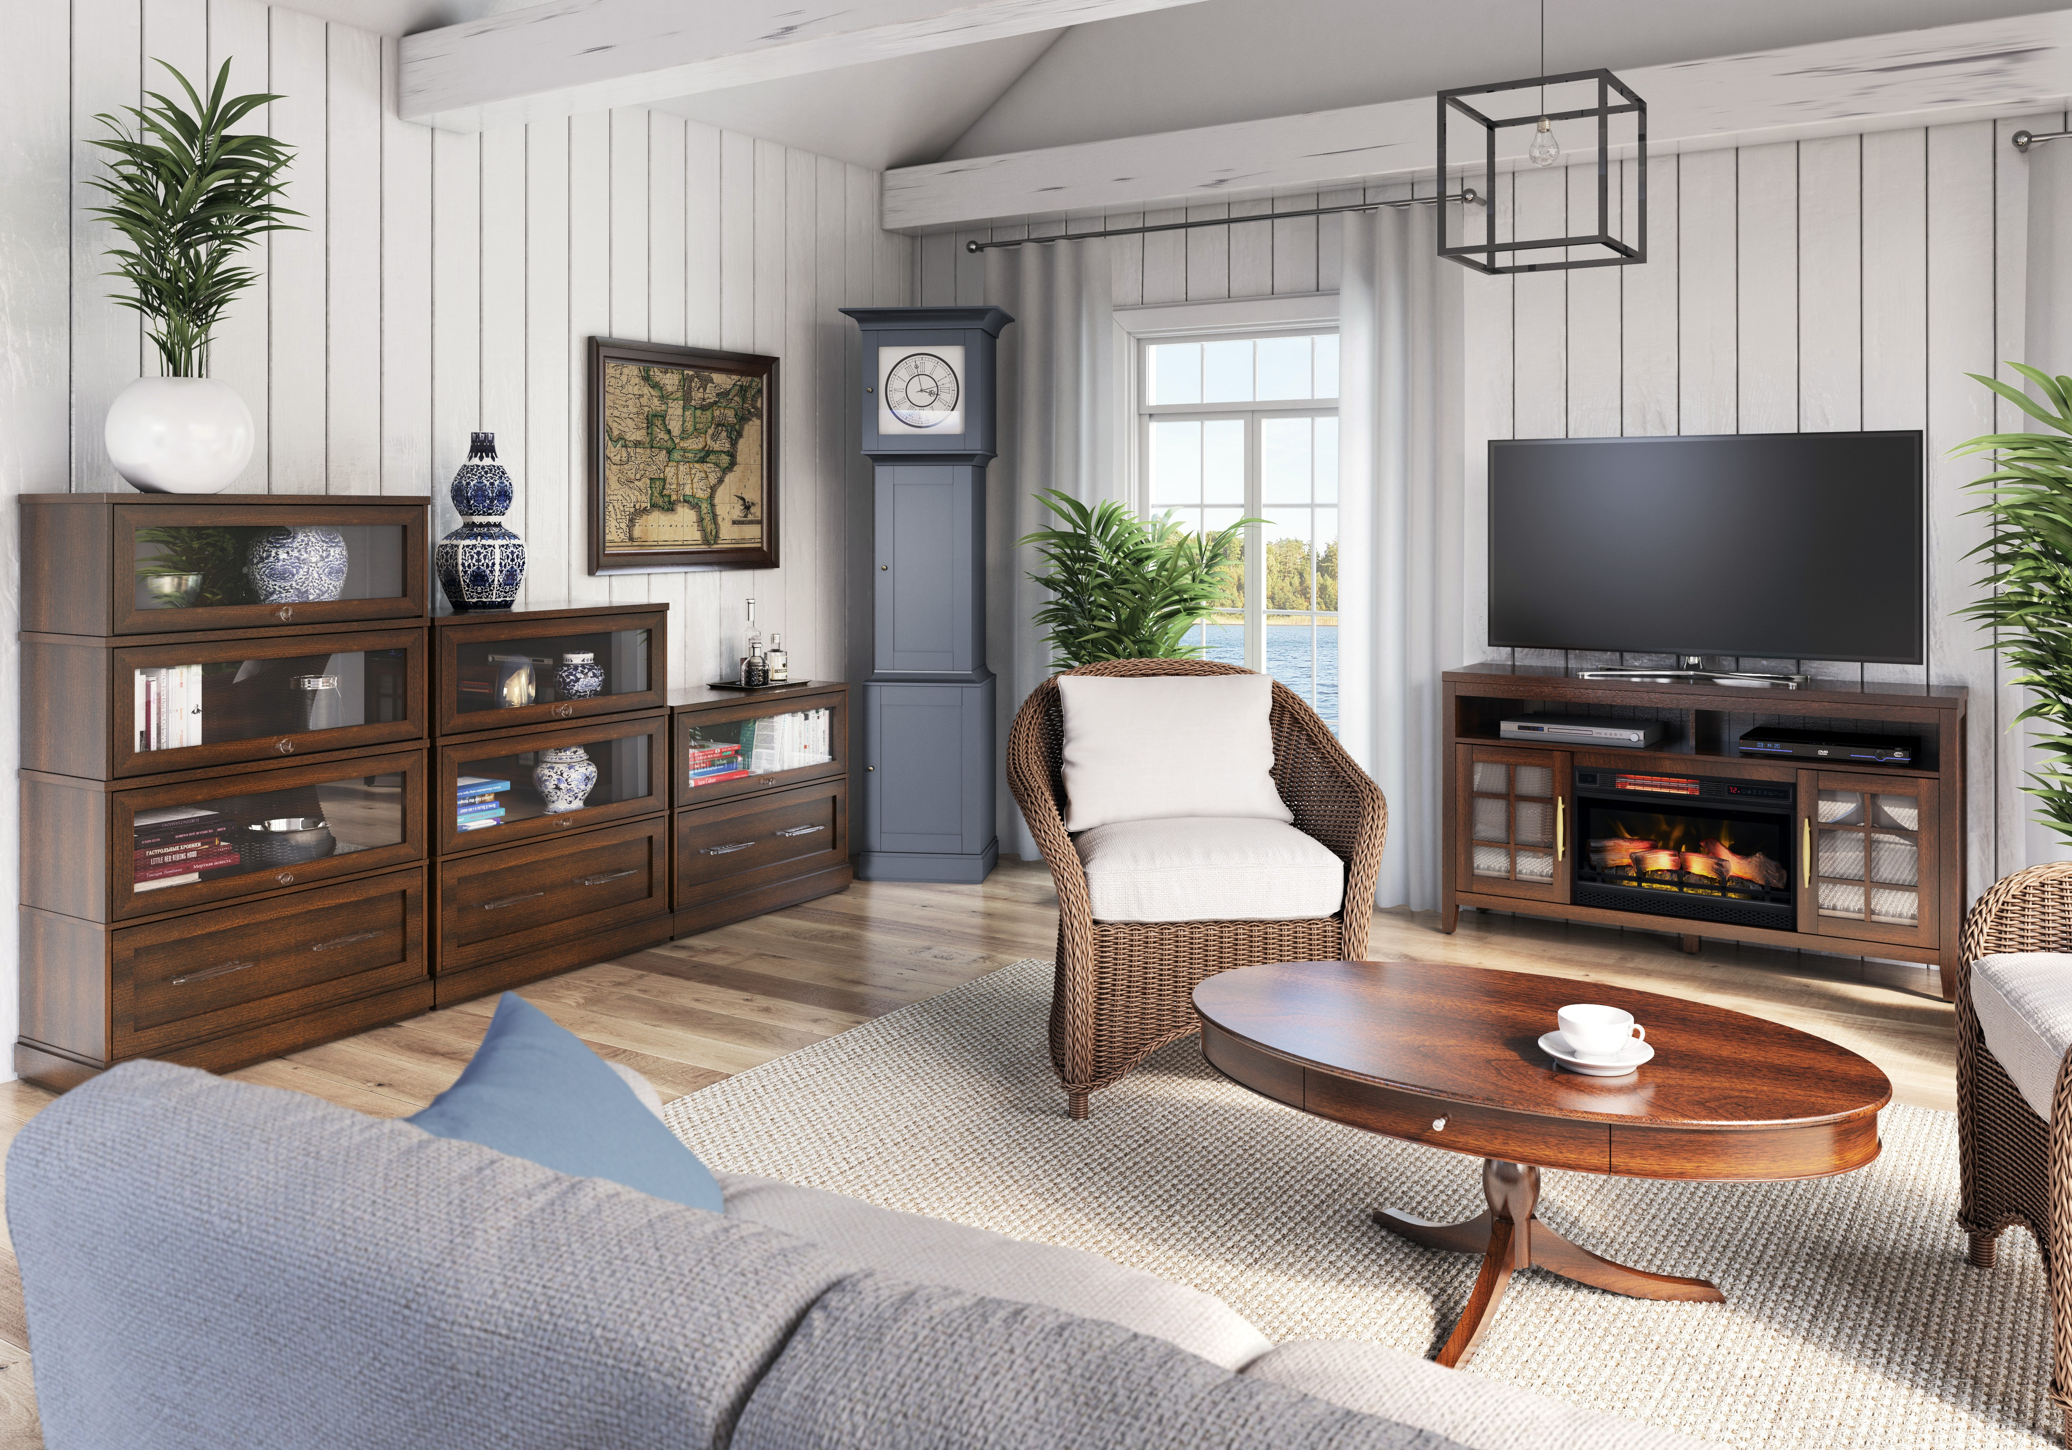

Twin Star Trompe L’oeil Room Scene
Featured in this image: Wine Cabinet with optional ClassicFlame® Infinity Electric Fireplace, Storage Cabinet with option Hutch, Adjustable Height Desk, and Side Table
