Contact: Cathy Lloyd
The Media Matters, Inc.
cathy@tmm.agency
336.956.2488

Spectra Home Expands Spectra USA
Quick Ship Program of Domestically Made Upholstery
Spectra Home also adding upholstered beds, chairs, side tables to Christina @ HOME Collection
High Point, NC, Oct. 16, 2021 – The big questions on retailers’ and designers’ minds are, “What’s in stock?” and, “When can I have it?” Spectra Home has the answers that they are looking for. Their Quick Ship Program of in-stock domestically made upholstery ships in 48 hours from their High Point warehouse. Cued up for the High Point Market, Spectra Home has added eight new groups to the Spectra USA Quick Ship Program creating a total of eleven groups in all. Retailers and designers can see them in the Spectra Home Showroom, 200 N. Hamilton, 213 North, by appointment and during the October High Point Market.
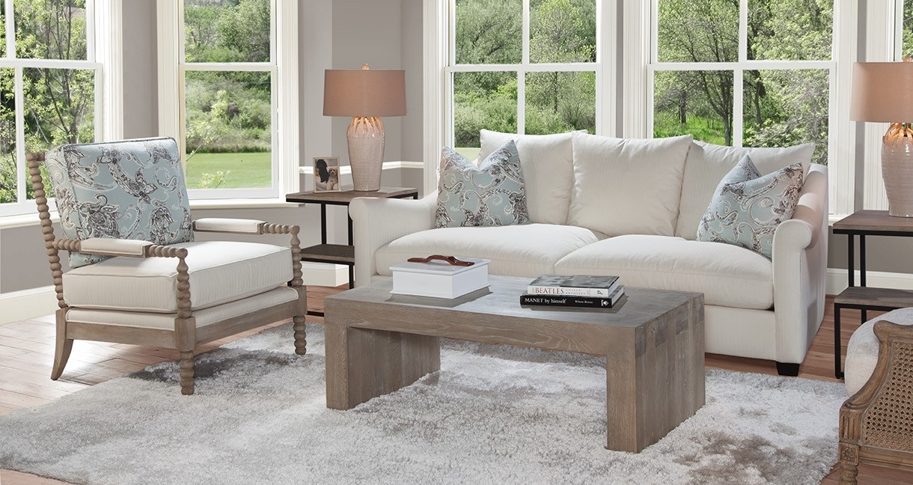

“Since we are a vertically integrated factory-owned furniture company, our in-stock inventory is in a good position,” stated Jim Telleysh, senior vice president of Spectra Home. “We have upholstery and the Christina @ HOME collection of upholstery and accents on the water and arriving weekly. Then on top of that we have our Spectra USA Quick Ship domestic upholstery, so we are shipping to our customers on a regular basis. Customers can also pick up orders by appointment at our High Point warehouse.”

The eight new Spectra USA Quick Ship upholstered sofa and chair groups in eye-catching silhouettes are covered in popular neutral color performance fabrics for today’s lifestyles. Spectra Home also offers 45 custom fabric selections that ship to customers in 10-12 weeks on average.

“We have expanded the Christina @ HOME collection to include four upholstered bed frames with button tufted and tailored accents,” Telleysh continued. “In addition, we are showing two new chairs and side tables in the Christina @ HOME collection that can be used in the family room or bedroom.” The new fully upholstered beds are named after Hollywood starlets Dunaway, Garbo, Hepburn, and Loren. In keeping with the California theme the new chairs are Bakersfield and Modesto, and the new side tables are Hollywood and La Brea.

# # #

About Spectra Home: Spectra Home designs and manufactures luxuriously comfortable, fashion-forward and exquisitely tailored upholstered furniture using time-honored construction techniques including hand-cut and -sewn fabrics and leathers. The company is based and warehouses product in High Point, NC. For more information, visit spectrahomefurniture.com, Facebook, Instagram, Pinterest.

