: 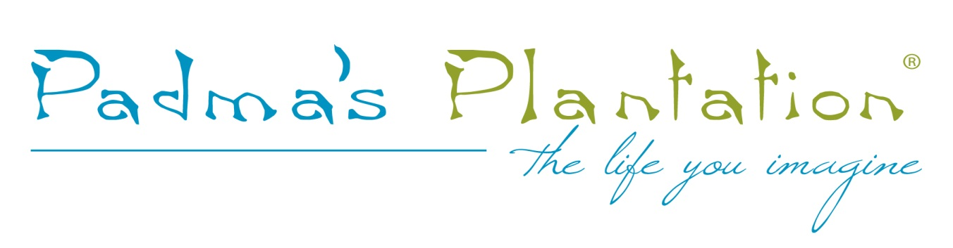

FOR IMMEDIATE RELEASE

MEDIA CONTACT:
Renee Maria Fanjon
Padma's Plantation Director of Marketing
(630)761-3100 x103
renee@padmasplantation.com

Padma’s Plantation to show in new Permanent Showroom at C&D Building during High Point Market.

CHICAGO, IL October_2_2017 Padma’s Plantation will be moving to and showing at its new permanent location at the High Point Market this
October. Their new showroom is at the C & D Building, 5th floor: 5L.

Recently, Padma's Plantation has taken a break from shows to focus on other types of marketing. “We feel that we need to go back to market now that our offering has grown and changed dramatically” states Renee Maria Fanjon, Director of Marketing for Padma’s Plantation. Among the introductions that will be shown are new slip-covered dining chairs with casters and swivel-rocking lounge chairs.

About Padma's Plantation – www.padmasplantation.com
Founded in 1997, Padma's Plantation is a nature-inspired company that focuses on crafting furniture of natural materials including renewable resources like bamboo, rattan, and abaca to create fine furniture and accessories that evoke the tropics and all it entails. Like the easy-going, laid back style enjoyed by those who live in warm climates, Padma's Plantation designs are casual and comfortable.

