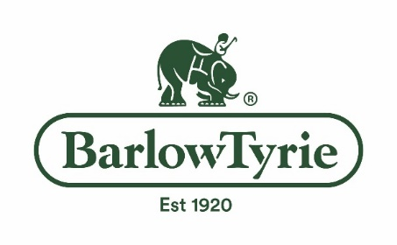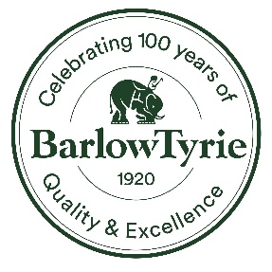

Barlow Tyrie Celebrates 100th Anniversary in 2020

Centennials are not a common anniversary; then again, England based Barlow Tyrie manufactures an uncommon product. Frederick Barlow and Victor Tyrie began their partnership in 1920 with humble beginnings – in a converted horse stable in central London.
What began as a two man shop producing hand-made, high quality teak benches and furniture for upscale gardens and public parks, is today a well-known and respected name in outdoor furnishings worldwide. Today we not only work with first quality, plantation grown teakwood, but with stainless steel and tubular aluminum.
A recipient of twenty international awards for design excellence, Barlow Tyrie continues to set high standards for designs that are considered “correct to the eye and the body.”
Still a family owned and managed company, we are proud of our heritage and in being the oldest remaining manufacturer of this very traditional English product.

Centennial crest logo attached.

Visit www.teak.com

