For immediate release

Castelle Introduces Resort Fusion Collection Inspired By Combination of Tropical and Contemporary Style

Ft. Lauderdale, Fla.- With a carefree casual feel, the RESORT FUSION Collection is slated to bring an effortless island vibe to the 2019 introductions from CASTELLE. Through a successful combination of tropically inspired elements and the simplicity of contemporary style, RESORT FUSION joins Castelle’s resort design furnishings to allow consumers to transport outdoor spaces into an island retreat look.
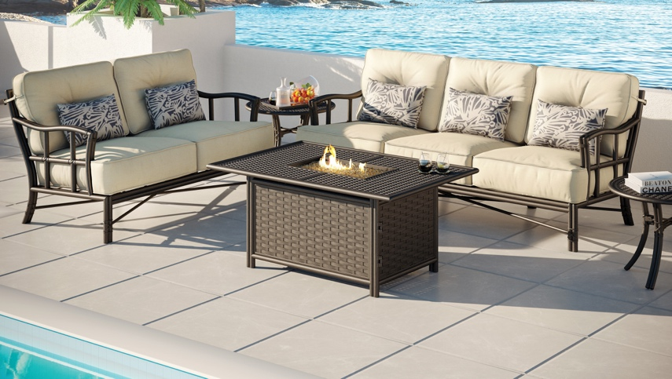
“There is a natural connection between outdoor living and tropical settings,” said Mark Stephens, president, Castelle. “With RESORT FUSION, our designers have successfully presented the resort-like experience in conjunction with modern design elements that are trending.”

Featuring rattan-look arms, legs and supports, this collection is constructed of cast and extruded aluminum. Resort Fusion offers relaxation through both cushion and sling seating. Gentle curves and grid-design supports are featured in combination with tailored cushions and sling fabrics in this collection. Lounge and dining options all feature a durable multi-stage powder coat finishing and optional artisan applied antiquing.

For more information about Castelle and luxury casual furniture, visit www.castelleluxury.com.
# # #
High Resolution images available. Contact: lrudd@pridefamilybrands.com

Pictured: Resort Fusion Collection Deep Seating with Fire Pit

About CASTELLE®.
For over 40 years, CASTELLE has distinguished itself in the manufacturing of award-winning luxury casual furniture. Innovation, state of the art manufacturing, and superior quality products are the trademark of CASTELLE and the reason CASTELLE is recognized as a leader in the casual furniture industry. CASTELLE has been the recipient of multiple Manufacturing Leadership awards for the Cast Aluminum category.
