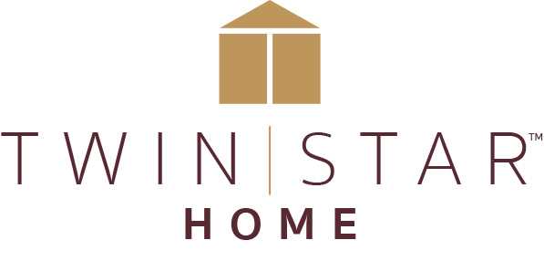

FOR IMMEDIATE RELEASE Media Contact: Calla Starr
calla@gefenmarketing.com
336.884.5020

TWIN STAR HOME EXTENDS SUCCESSFUL ACTIVELIFE DESK SERIES
Three New Adjustable Height Desks Offer Expanded Style Options

Delray Beach, FL (October 8, 2019) – Twin Star Home, the market leader in electric fireplaces and a premier designer and manufacturer of home furnishings, has added three new desks to its popular ActiveLife™ series of adjustable height desks. The new ActiveLife desks will be on view at the High Point Market in October.

“We are really excited about the debut of these three desks,” said Jimmy Junker, Twin Star Home’s Vice President of Product Development. “We have been leaning into this category and focusing on design approaches that marry innovation and multifunctionality with styles that give consumers the flexibility to use the desks in any area of their home above and beyond a typical home office. These desks are perfect for living rooms and family rooms too,” said Junker.

Designed for both home and office use, the ActiveLife series comes with three programmable height settings and a range of built-in features including the patent pending Illumitouch™ seamless control panel. The new desks include a sleek contemporary design in black with a Black Marble glass top; a rustic trestle design in a light Bloomfield Oak finish; and a simple pared down design in an Antique Brown Cherry finish.

All easy-to-assemble ActiveLife desks offer three adjustable heights that range from 29.5” to 47”; the quiet built-in motor is operated from a lighted control panel on the desk’s ergonomic top. A built-in ActiveLife timer gives periodic reminders to stand up and move around, and other features include a multiport charging station, a glass top that is dry erase compatible, and a partitioned storage drawer for small items.

The Twin Star Home showroom is in Market on Green, #602.

ShareFile Link to Images: https://gefen.sharefile.com/d-s3de1112f48e47a98

Link to YouTube video: https://youtu.be/lM4i2xJvSSk

###

About Twin Star:
Twin Star Home of Delray Beach, FL is an award-winning manufacturer of home furnishings, including electric fireplaces and furniture, many with integrated media solutions. Twin Star Home combines the latest trends with consumer-driven innovation and design-rich style to create lasting products that enhance consumers’ lives. Twin Star Home is recognized for its trusted national brands: ClassicFlame®, Duraflame, Bell’O, Tresanti and ChimneyFree. Find out more at www.twinstarhome.com.

