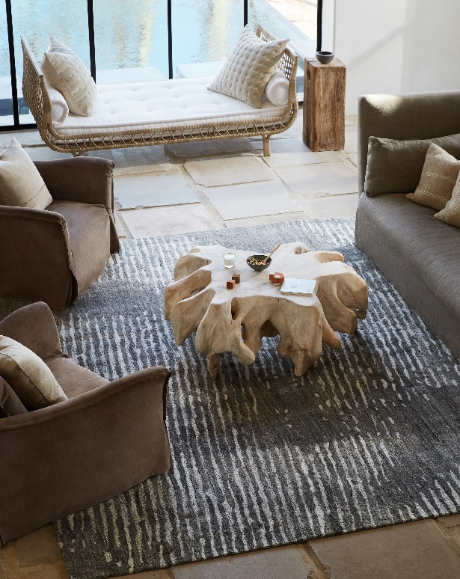

JAIPUR LIVING INTRODUCES EXQUISITE HANDMADE AND VERSATILE POWER LOOMED COLLECTIONS, HIGHLIGHTS BEST SELLERS FOR THE MONTH OF MAY

(Acworth, GA—April 22, 2021) Global rug and textiles furnishings company Jaipur Living greets the month of May with all new designs, fresh accessories, and a special nod to the best-selling designs that have resonated with so many of its customers. The new collections will be shoppable on the Jaipur Living website in May.

“We’re excited to be introducing amazing artisan-crafted handknots designers will love as well as classic options at accessible price points for new homeowners,” said Jaipur Living Vice President of Product Design and Development Steve Sorrow. “We also wanted to shine a spotlight on the company’s best-selling collections like Salinas – perfect for those who want an authentic vintage look that can be customized.”

By the numbers:
- Almost 50 new rugs are being introduced across one existing and seven new collections
- Four new hand-knotted and handwoven lines
- Four new power loomed and indoor-outdoor lines
- Eight poufs in popular colors added to the Spectrum Rays performance collection
Trends:
- Urban Curator - a sophisticated take on classic, as embodied in the Orenda collection
- Modern Folk – a classic trend that incorporates forward colors and stunning prints, as incorporated in the Realm collection
- Turkish Sunfades - purposefully faded designs inspired by Turkish designs as seen in the Blythe collection
New Favorites:
ORN01 Orenda Kerensa Hand-knotted from 100% wool, the Orenda collection features classic patterns and versatile colors for a timeless look that blends with a variety of styles. The Kerensa rug comes in a stately blue and gray vintage-look pattern.
ORN02 Orenda Amalia The Orenda collection’s Amalia rug features an updated traditional trellis, chain, and tiles pattern in a subtle green and gray color palette.
ORN03 Orenda Cerelia The Orenda line’s Cerelia rug boasts a soothing vintage-look pattern in soft blues and grays that complement updated traditional décor.
REA01 Realm Eladyr Made from 100% real silk, the hand-knotted Realm collection is extremely soft, featuring on-trend colors and timeless patterns for a blend of contemporary and classic. The traditional, vintage-look Eladyr rug is stunning in gold and white.
REA02 Realm Merith The Realm collection’s Merith rug displays a vintage-look pattern in pinks and grays, lending updated traditional style to modern, sophisticated interiors.
BLY02 Blythe Arlowe The hand-woven Blythe collection features a wool-blend cut-loop pile and a soft, textural feel. Transitional, soft colors play on global patterns for a look that is universally flattering. The Arlowe rug features a vintage-look pattern in a white and tan colorway.

ABL09 Abrielle Lysandra The easy-to-design-with Abrielle collection of power loomed rugs blends a low, plush pile with updated traditional designs. Easy to care for and ideal for high-traffic spaces, the multicolor and blue Lysandra rug brings modern style to transitional rooms.
SMR09 Spectrum Rays Asila The Spectrum Rays line brings the look of our popular indoor Spectrum pouf outdoors with a polyester construction. The collection presents eight on-trend colors, all of which convey Scandinavian texture thanks to a braided solids and heathers design.
In Stock Best Sellers:
PVH10 Pathways by Verde Home Stockholm Directional micro-tufting and a high-low pile help to create the mid-century modern appeal of the wool-blend Pathways by Verde Home collection. The Stockholm rug displays a painterly linear motif in soft, versatile tones.
SLN14 Salinas Cosimo The Salinas collection of 100% wool rugs emphasizes the Old Modernity trend with traditional, intricate details and a soft hand-knotted construction. The neutral Cosimo rug makes a transitional statement with grounding hues and Kotan-inspired motifs.
BRR02 Brier Parra The Brier collection blends intricate scrolling patterns and organic, earthy neutrals. The hand-knotted Parra rug captivates with fine, filigree details in a relaxed ivory, green-gray, and light blue colorway.
SPT09 Someplace in Time Pendulum Inspired by the detail and originality of antique Bijar carpets, Someplace in Time is a beguiling collection of Afghan wool handknots representing both heritage and the contemporary. The Pendulum rug grounds spaces with its luxe appeal and earthy colors -- available in programmed and custom sizes.
ZUI01 Zuri Zola Modern Moroccan style defines the contemporary Zuri collection of 100% hand-knotted rugs. The chic Zola design showcases a classic lattice pattern in neutral ivory and brown.
KDK01 Kaleida by Kavi Lucida A traditional grass pattern makes the hand-knotted Kaleida by Kavi collection easy to design a room around. Soft and textural in blues and blacks, the Irminia design is crafted in a blend of wool and viscose.
JUT01 Juliette Arabella The handwoven Juliette collection features layers of neutral tones and a subtle texture created by hand-printed patterns. The Arabella rug’s gray and white colorway makes it a sophisticated accent that grounds a space while adding extra dimension with its on-trend abstract design.
About Jaipur Living
Jaipur Living is a global lifestyle brand with a passion for people, product, and design. Known for its luxury rugs, poufs, pillows, and throws, Jaipur Living operates with a mission to create beautiful lives for its employees, customers, and artisans—all while preserving the age-old craftsmanship of handmade rugs. Through social initiatives and the Jaipur Rugs Foundation, the company supports more than 40,000 artisans in 600 villages across India by providing them with a livable wage, access to health care, leadership education, and opportunities for personal growth and development. Combining time-honored techniques and of-the-moment trends, every Jaipur Living product is as meaningful as they are beautiful.
More Information:
www.jaipurliving.com
Media Contact:
sasha.wallace@jaipurliving.com
SOCIAL:
- https://www.instagram.com/jaipurliving/
- https://twitter.com/jaipurlivinginc
- https://www.pinterest.com/JaipurLiving/
- https://www.facebook.com/jaipurliving
- https://www.linkedin.com/company/jaipur-living-inc

