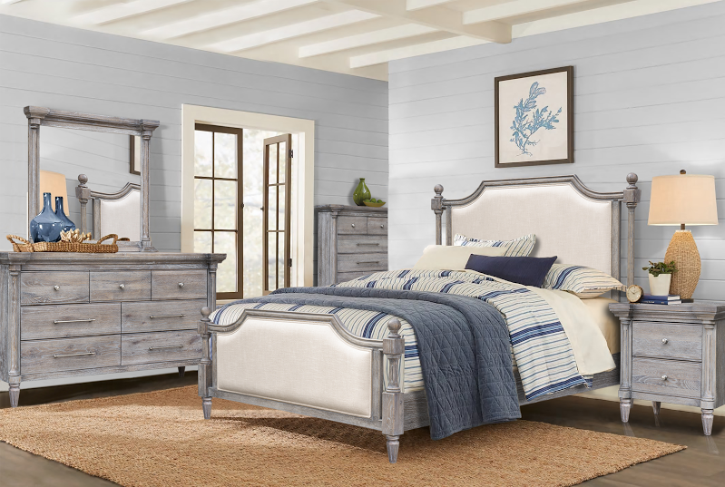
The Grey Summit collection has a charm all its own that sets it apart from most Cottage Creek offerings. From the silken upholstery and curvilinear elegance to the dignity of fluted columns, any room furnished with this set will surely beckon its owners with both comfort and sophistication.

High Point Showroom: Warehouse:
The Profit Center 3415 Hwy 53
156 S Main St. Huntsville, AL 35806
Show Phone Number: Office Phone Number:
561-339-1268 256-852-9777

