Watermark LivingTM Hosts Sunbrella Lunch ‘N Learn CEU Presentation

At High Point Market

“Well Being and Design: Elements of Positive Environments” will be the topic of the Lunch N’Learn presentation hosted by Watermark Living during the High Point Market. Speaker for the presentation, Marcia Blake of Sunbrella will speak about designing healthy spaces and using colorful textiles in outdoor décor. A luncheon will be be served for all attendees who can also earn CEU credit. The function will take place Monday April 8 from 12 noon to 1pm.

March 26, 2019 – Largo, FL – Watermark LivingTM announces it will host a Lunch ‘N Learn during the April High Point Market featuring Marica Blake, merchandising manager, Glen Raven Custom Fabrics. “Well-Being and Design: Elements of Positive Environments” is the title of the CEU eligible presentation that will be held in the Watermark Living showroom at 205 S Main Street on Monday, April 8, from 12 noon until 1 pm.
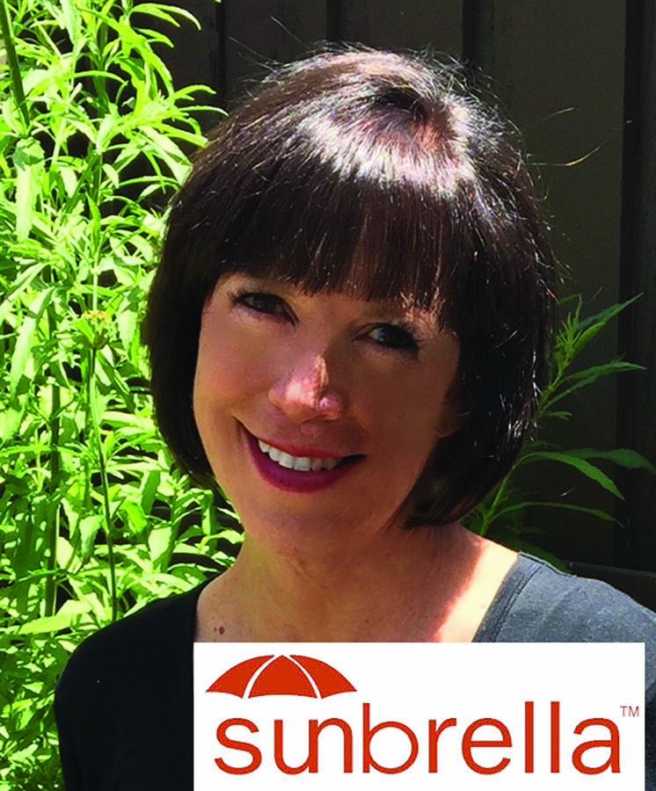
“Watermark Living is proud to be participating in the Lunch and Learn presentations during the High Point Market for the benefit of market goers,” said Chad Harper, national sales manager, Watermark Living. “Glen Raven’s Sunbrella is an amazing partner for this presentation, and we look forward to the offering of this timely topic.”

Focusing on designing healthy spaces using colorful textiles, Blake’s talk will include discussion of how to create effective color palettes utilizing textiles for healthy lifestyle settings indoor and out. Participants will gain knowledge and understanding of the benefits of integrating color and in the selection and specification of performance fabrics in lifestyle designs for personal health and well-being.

“By the end of this CEU, participants will have learned how color influences emotions and behavior, impact health and well-being,” says Blake. “How color schemes can be used with textiles for personal health and how color combinations can improve well-being will also be included in the presentation hosted by our friends at Watermark Living.”

Attendees will be provided a delicious lunch and earn 0.1 CEU credits. As seating is limited, interested market attendees must RSVP for the Lunch ‘N Learn by contacting info@watermark-living.com.

For more information about Watermark LivingTM and its line of quality products, visit www.watermark-living.com.
# # #
About Watermark LivingTM.
Watermark LivingTM is a complete casual resource with more than four decades of dedication in sourcing quality outdoor and rattan products designed and proven to stand the test of time. Created by retailers for retailers, Watermark LivingTM provides fashionable product that is highly customizable with quick turn-around times, from deep seating to casual dining, lighting and accessories. www.watermark-living.com
Editorial Requests: Contact: Laurie Rudd. lrudd@laurieruddpr.com

