FLEXSTEEL’S BRAND GETTING A CONTEMPORARY UPDATE
Traditional Maker’s New Lifestyle-Driven Look and Feel Come Into Sharper Focus

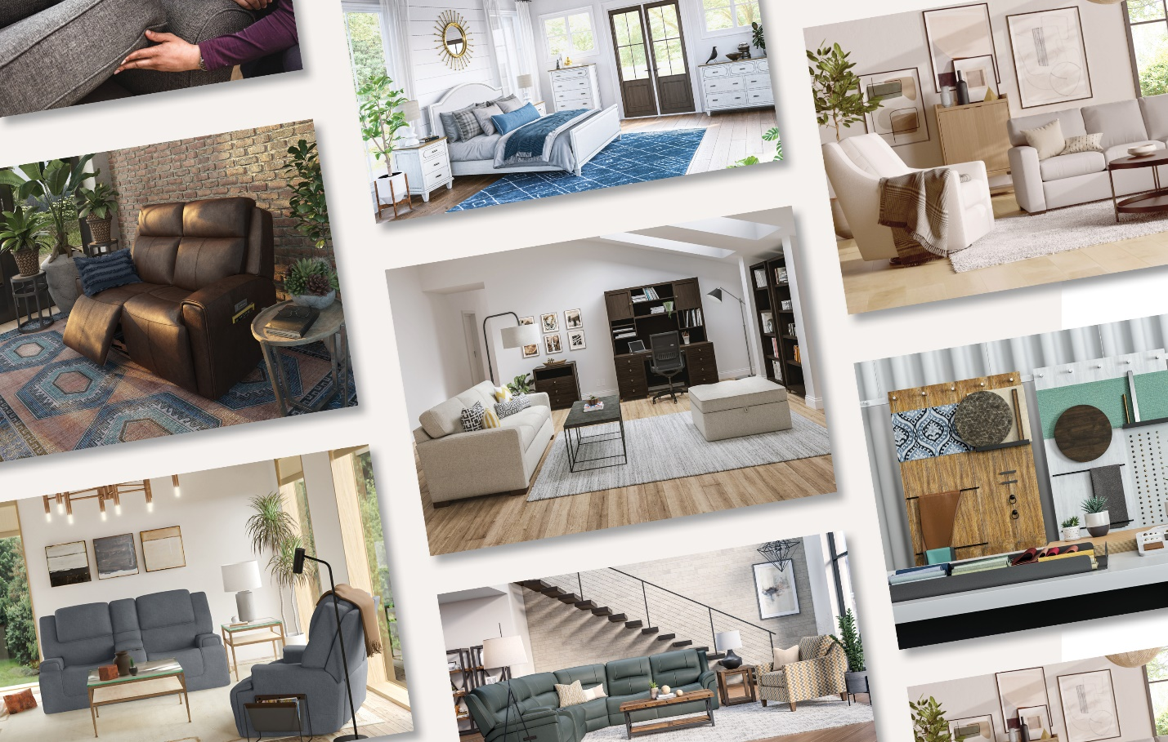

Dubuque, IA—August 13, 2021—The launch of a new corporate website last month was the first indication that something big is currently underway at Flexsteel: A major update of the brand.

The entirely new Flexsteel.com is a head-turning departure for one of the industry’s most reliably traditional furniture brands. Styled like the cool, clean sites of lifestyle-driven specialty retailers, it is the first volley in a major refresh that will no doubt call to mind the time that Oldsmobile invoked fathers. Certainly, like the storied automotive maker, Flexsteel won’t be the first traditional stalwart that has aimed to attract a new generation of buyers with a sleek new look and attitude, executives say. But when all is said and done, the initiative promises to be far more comprehensive than a revamped website might suggest.

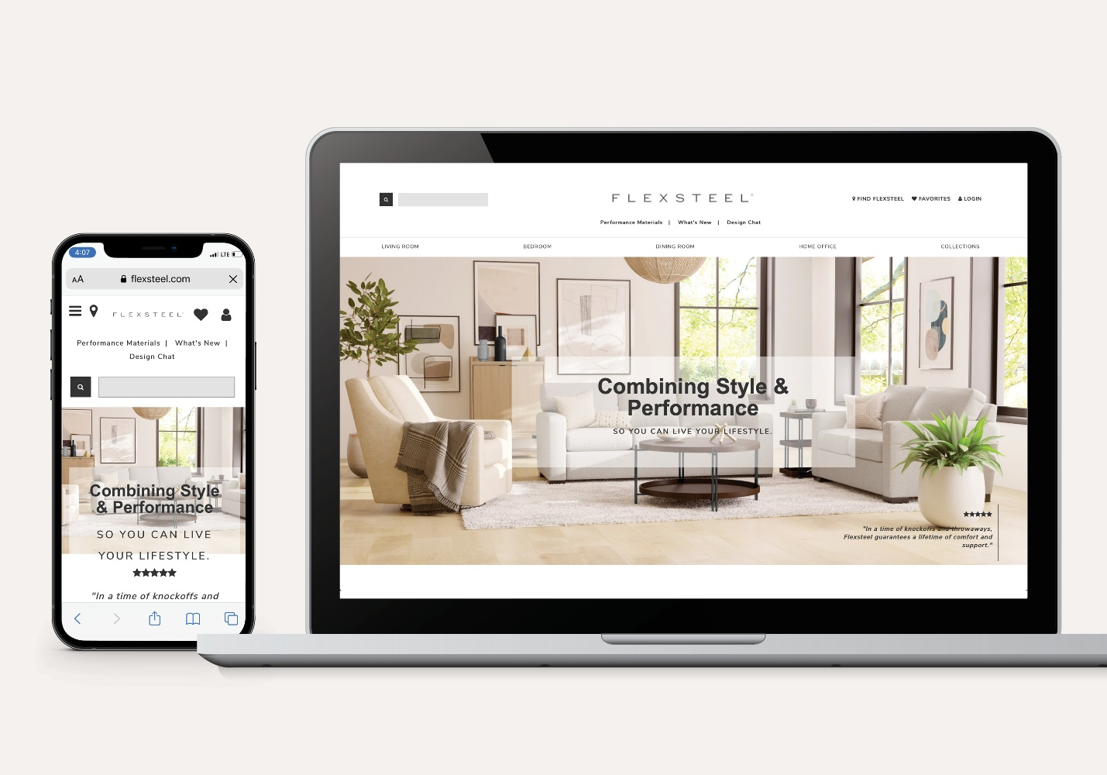

For starters, there’s no tagline here destined to become a pop culture catch-phrase. Rather, says Sharad Mathur, vice president of marketing for Flexsteel, “Look for our brand refresh to be much more…subtle. As we’ve been developing our new brand guidelines, we’ve been working closely with dealers across the country, exploring what it takes to attract a younger audience now. The consensus was clear: Our dealers don’t need pictures and funny taglines. What they do need are clean and simple design elements that blend seamlessly into their stores, and that’s very different from how furniture manufacturers have presented their brands at retail in the past.”

Also very different is the collaborative approach Flexsteel has been quietly undertaking throughout the brand refresh process, communing closely with independent retailers across the country prior to the big reveal set for this October. “We’re on the journey with them,” describes Laura Crowley, owner and general manager of Crowley Furniture, a three-store chain based in Kansas City. “It’s not ‘here’s what we’re doing, take it or leave it.’ They are interested in what’s important to us because they want to ensure we come out with a great end-result, and ultimately, we’re going to carry that brand out to the consumer. From a marketing standpoint, it’s fascinating to see a traditional furniture brand taking the best of that world and shifting into a new, more lifestyle-driven era. It’s a really interesting mix and I’m excited about moving forward.”

“Their new website is so much more upscale than it ever has been,” notes Tom Balistreri, owner, and vice president of merchandising at four-store Colder’s Furniture and Appliance located in the Milwaukee area, adding that he too has been in close communication with the Flexsteel team. “They understand that we’re the conduit to the consumer, and that as a national brand, they need to have a consistent presentation. You can’t have a beautiful website, and then displays that are a mess in-store, with no matching point-of-purchase materials. We’ve talked at length about that, and the importance of gallery refreshes, to ensure that we are giving the consumer the right experience of the Flexsteel brand.”

It All Matters

According to Mathur, the key word throughout the brand refresh journey has been “consistency,” in everything from the most obvious—a revised logo, new hang tags and in-store signage—to the not-so-obvious, like email signatures and PowerPoint templates for both internal and external audiences. “From letterhead to sell sheets, every interaction is an opportunity to build our brand,” he says. “And it all matters because we’re trying to attract a younger audience. Consumers are again becoming brand conscious, and that’s particularly true with younger shoppers. Gen Y cares about what companies stand for, they care about responsible practices, they care about the look and feel of brands. They will not do business with you just because you’ve been around for 100 years.”

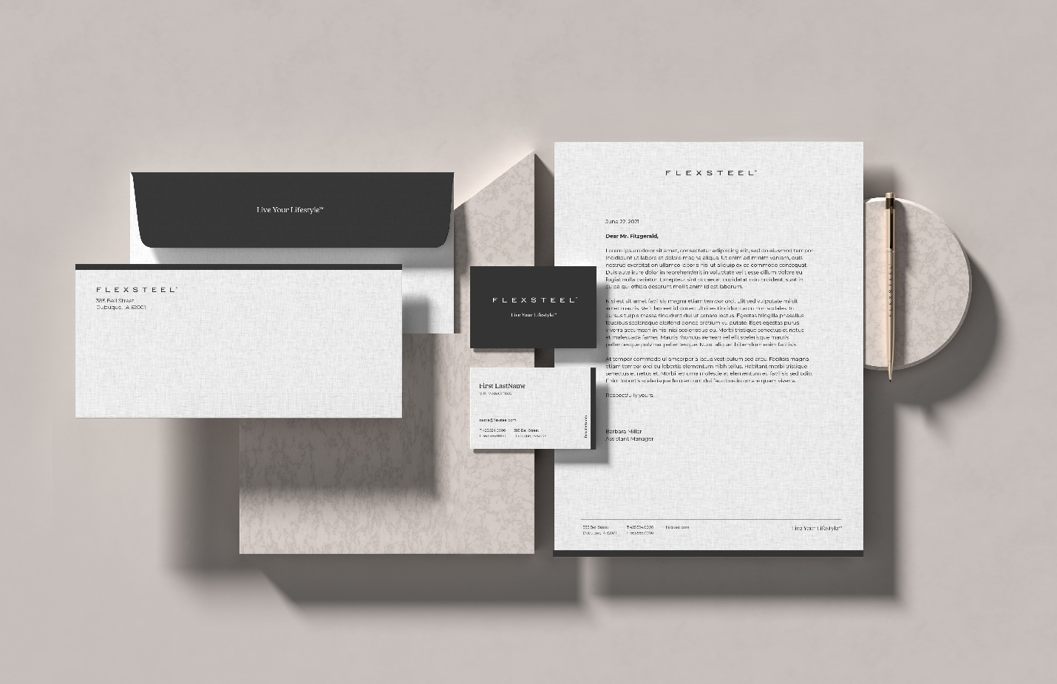

About that logo: “Older generations tend to not pay a lot of attention to a logo’s color or how long it’s been around,” Mathur relates. “We had multiple versions, there was no consistency corporately or at the store level and none of them meant anything to most people. Theoretically the different logo versions referenced blue steel springs, but people could not really figure out what the logo meant. Overall, the Flexsteel brand looked like it was stuck in the ‘80s. We resembled IBM…old, dated and basic blue.”

In an effort to appear more up to date, “with a clean look indicative of specialty retailers, the type that make people think, ‘I can see this furniture in my home because this company understands me,’ Mathur has begun developing buyer personas to help everyone identify Flexsteel’s target consumer and what they seek. Even more important, he developed in-depth brand guidelines, for use both by dealers and the corporate team that clearly lay out what Flexsteel stands for, its voice (think more conversational than corporate), imagery (spaces with a lived-in feel full of natural light) and the overall tone. As hinted at by the new website, that tone is one of a helpful, decorating ally for retailers and consumers, just as reliable and familiar as it has always been, yet quite at home in the digital age.

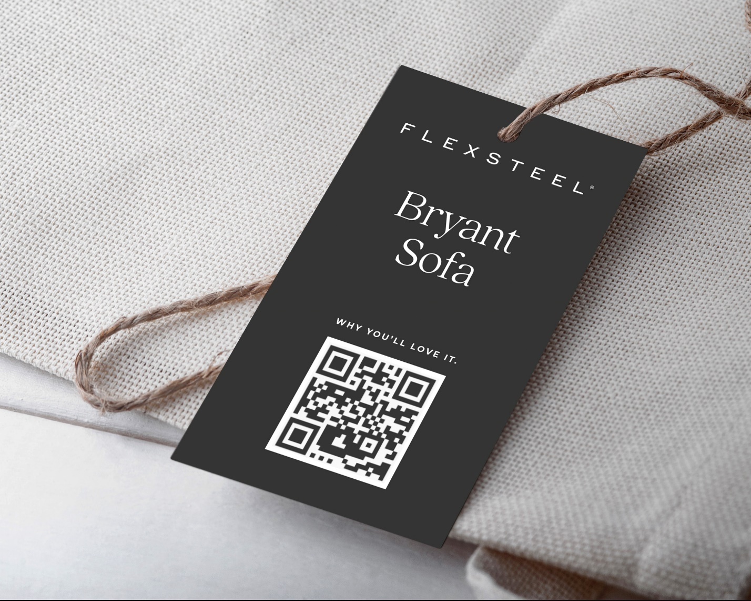

Blue Skies

While Flexsteel is moving to recast perceptions about its image as a very traditional concern, nothing has changed in terms of what made the company successful in the first place: Quality products that will last thanks to that proprietary blue steel spring™ frame, a patented ribbon of steel that revolutionized upholstered furniture manufacturing when it was introduced in the 1920s. And that legacy, retailers say, is why Flexsteel is a brand poised to come into its own.

“They are repositioning the brand in an interesting time,” Balistreri points out. “During the pandemic, I spent more time on the salesfloor, and I was really impressed by the number of young people that were buying houses. They are willing to spend more, and they are willing to wait, to step up to a better quality of product at a time when Flexsteel has been changing their merchandising to become a lot more fashion-forward and younger looking. I think spending more time at home has only accelerated that trend, because many of them had purchased furniture to fill a void. It was functional, maybe it looked pretty good, but it didn’t hold up and they realized it also wasn’t that comfortable.”

Crowley agrees. “We’ve definitely seen a change during the pandemic and we’re selling more high-quality furniture than we probably ever have. I think people have been burned a little bit when they bought something that was off-brand and not really the quality they wanted. Consumers now are more interested in quality products, where they are made, what’s going into them, and that’s true no matter their age category. So, when you can speak to the brand’s history, while also being relevant in style, I think that’s kind of a magic mix. I’m really excited about what they are doing.”

# # #

