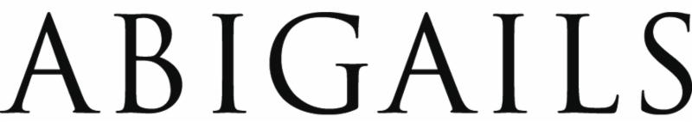

FOR IMMEDIATE RELEASE

Ned Voelker, President
Abigails
3219 Industrial Street
Alexandria, LA 71301
800-678-8485

Web: www.abigails.net
Email: marketing@abigails.net

High Point Market
Interhall 406

ABIGAILS is Expanding the Holiday Collection with Glass Trees

Alexandria, LA - October 1, 2021

At this month’s High Point market, Abigails will add green/clear glass trees to the Holiday Collection. These handmade glass pieces are the perfect size for gift giving and perfect for the winter season.

The collection comes in 3 sizes and is available in green/clear and clear glass. The small tree is 4.5”D x 8”H and retails at $53.00 each (for the clear) and $70.00 each (for the green/clear). The medium tree is 4.75”D x 9.5”H and retails at $65.00 each (for the clear) and $77.00 each (for the green/clear). The large tree is 4.5”D x 11”H and retails at $70.00 (for the clear) and $84.00 (for the green/clear).

Abigails will introduce the new bamboo cachepots at the High Point Market, October 16-19. Abigails Showroom is located in the IHFC Building, InterHall space IH406.
