Contact [Contact]  Telephone 336.838.5178  Cell 804.931.8171  Email press@johnstoncasuals.com  Website johnstoncasuals.com | FOR IMMEDIATE RELEASE  April 20, 2017
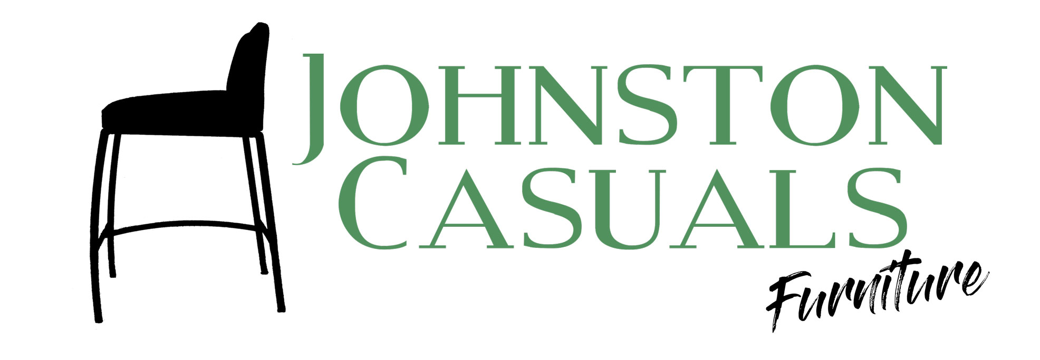

Johnston Casuals Continues Craftsmanship with New Designs

North Wilkesboro, NC, April 20, 2017– Johnston Causals Furniture is the last remaining manufacturer in the once booming furniture making hub of Wilkes County, North Carolina. While many American manufacturers were moving jobs overseas, owner Joe Johnston stayed true to his roots by investing in the local tradition of craftsmanship. In doing so, he found that many customers ultimately care more about quality than price.
Johnston found he could deliver high quality products at fair price by relying on the workmanship and dedication of talented welders, fabricators, grinders, and upholsters like long-time employee, Chris Souther. Souther is a Wilkes County, NC native with over 20 years of experience with Johnston Casuals. He learned his trade in high school and in the Army National Guard, and has since become an integral member of the Johnston Casuals manufacturing team.
Once Johnston approves a new CAD design from the design team, Chris brings it to life with welding, drafting, and fabrication. Souther’s role also involves coaching and mentoring other company craftsman how to continue the tradition of creating unique, detail-oriented products that serve both form and function. When asked what he does for a living, Chris says “A little bit of everything… every day is a new product, it keeps things interesting.”
New 2017 market introductions include designs from John LeShane, Broussard Walker, and Michael Wolk. At the 220 Elm showroom in High Point, Johnston Casuals will show new dining tables, dining chairs, barstools, bench seating, occasional tables and dog beds. In addition to their new designs, Johnston Casuals will also be unveiling a new premium finish that can be applied to many of their new and existing products.
Johnston Casuals Furniture manufactures contemporary furniture using 97% recycled Southeastern USA steel in their factory in North Wilkesboro, NC. Now in our 36th year, we pride ourselves on providing design products to our customers at competitive market prices. Our design showroom is located at 220 Elm, Level 3, Space 306. Please contact Ashley at press@johnstoncasuals.com if you’d like to tour our facilities or meet craftsman Chris Souther.
# # # #
If you would like more information about Johnston Casuals, please contact Ashley at 336.838.5178 or email press@johnstoncasuals.com.

